Shekhar B.
PhD, Professor and Head, Division of Criminology and Forensic Science
Karunya Institute of Technology and Sciences, Coimbatore, India
Abdullah A.K.S.
PhD Scholar (Criminology), Karunya Institute of Technology and Sciences, India

UNDERSTANDING THE CRIME-CLIMATE NEXUS THROUGH THE CRIMEATE LENS: A BRICS VISION FOR ECOLOGICAL COOPERATION AND CRIME PREVENTION

Keywords: climate change; crime; human trafficking; crimeate framework; BRICS nations; ecological justice; quintuple helix model.
Аннотация. В статье представлена концептуальная модель CRIMEATE, исследующая взаимосвязь изменения климата и преступности в странах БРИКС. Усиливающиеся экологические потрясения разрушают не только природные системы, но и социальные механизмы защиты, подвергая маргинализированные группы повышенному риску эксплуатации, торговли людьми и насилия. В основе анализа лежат теории рутинной деятельности, общего напряжения, «зелёной» криминологии и гипотеза биоагрессивности. Биологические данные демонстрируют, как жара, загрязнение и стресс после катастроф влияют на агрессивное и импульсивное поведение. Сравнительный анализ пяти стран (Бразилии, России, Индии, Китая и Южной Африки) показывает, как экологическое давление и институциональная хрупкость способствуют росту преступности. В рамках CRIMEATE выделяются три ключевых индикатора риска: интенсивность катастроф, перемещение населения и утрата опеки. Предлагается дорожная карта экологической справедливости на уровне БРИКС, включающая системы раннего предупреждения, протоколы против торговли людьми и модели правосудия, ориентированные на жертв. В завершение представлена модель «пяти спиралей» устойчивости, объединяющая государство, науку, общество, бизнес и природу в единую систему предупреждения экологически обусловленной преступности.
Ключевые слова: изменение климата; преступность; торговля людьми; концепция crimeate; страны БРИКС; экологическая справедливость; модель пяти спиралей (quintuple helix).

Introduction
“Before the Earth becomes uninhabitable due to temperature rise, it may already be made unlivable by climate-induced wars.”
The impacts of 'climate change' are no longer just happening in the backyards, streets and workplaces of communities or as environmental and biodiversity degradation. The transformation of the climate into a criminogenic force reshapes human vulnerability, erodes the defences of the state and social system, and creates new zones for criminal penetration. The BRICS countries (Brazil, Russia, India, China and South Africa, collectively represent a substantial portion of the world’s population, ecological hotspots, and developing economies, making them uniquely positioned to both experience and respond to this nexus of environmental and criminal risk. In this venture, the underexplored connection between climate change and criminality paved the way for authors to come up with a novel framework, the CRIMEATE, a theoretical union of CRIME + CLIMATE accounting for the new epochal overlaps between ecological disturbation and the changing crime world. The authors through the CRIMEATE framework, shift the discourse from viewing environmental degradation as merely a humanitarian or developmental concern to recognizing it as a catalyst for organized crime, trafficking, violence, and governance breakdown. This paper explores these links through interdisciplinary theory, fieldwork, and cross-national examples, culminating in a roadmap for ecological justice and climate-resilient crime prevention.
Merging Ecology and Criminology
The link between environment and crime isn’t new. As early as the 1830s, Adolphe Quetelet, a Belgian sociologist, noted that crime isn’t just about personal choice – it often follows patterns shaped by conditions like poverty, overcrowding, and seasonal changes. His early insights paved the way for today’s understanding that climate change can be a driver of crime, not just a distant environmental issue.
Routine Activity Theory helps explain how disasters change daily life in ways that make crime more likely. When floods or droughts displace communities, families lose their homes and routines. Women may be left without safe housing, children unsupervised, and police forces overstretched. This creates a space where traffickers and exploiters thrive, preying on those left unprotected. General Strain Theory shows how chronic environmental stress, like crop failures, rising debt, or climate-forced migration, builds pressure. When people can’t find work, get educated or feel secure in food and housing, some of them commit crime out of desperation. This strain is economic and emotional for many in BRICS regions, formed by the residue of death, displacement and constant uncertainty. Green Criminology has a wider perspective: It sees harm to the environment as harm to people, especially the poor. Illegal mining, pollution, and deforestation not only destroy nature; they drive indigenous peoples and low-income communities into more vicious cycles of exploitation. Often, it’s state failure or corporate greed that allows this double victimization to continue unchecked. Finally, the Bioclimatic Aggression Hypothesis explores how heat affects our brains. Studies show that extreme temperatures can raise testosterone and cortisol, while lowering serotonin, making people more prone to anger, impulsivity, and violence.
Biological Responses to Climate Extremes
While criminological theories offer crucial insights into the structural and environmental determinants of crime, advances in biological and neurological sciences reveal that climate extremes can directly affect human physiology and behavior. These biological pathways help explain the micro-level responses to macro-level environmental stressors, linking heat, pollution, and disaster trauma to shifts in aggression, cognition, and decision-making.
Heat and Aggression
High temperatures have been shown to activate the hypothalamic–pituitary–adrenal (HPA) axis, a central stress response system. This activation leads to elevated levels of testosterone and cortisol, while simultaneously suppressing serotonin, a neurochemical associated with mood stability and impulse control (Anderson et al., 2000). The neuroendocrine disruption caused by extreme heat results in heightened irritability, impulsive behavior, and aggressive acts of violence including both physical assaults and sexual offenses. These traits biologically relate to surges in interpersonal violence. The risk is exacerbated by urban heat islands, which are common in densely populated cities of the Global South. Research indicates that certain neighborhoods which suffer from insufficient greenery and poor ventilation, as well as inadequate cooling infrastructure, experience much higher rates of violent crime during heat waves.
Stress and Post-Disaster Crime Surges
Environmental disasters such as floods, cyclones, droughts, and wildfires often serve as acute trauma triggers. In the wake of these disasters, survivors frequently experience heightened levels of cortisol and adrenaline, stress hormones that can impair judgment, reduce empathy, and increase risk-taking behavior. Psychological distress following disasters, marked by loss of home, income, or loved ones, creates conditions of desperation, in which survival strategies may cross into the realm of criminality or exploitation. Research stemming from Hurricane Katrina in the U.S. and Typhoon Haiyan in the Philippines indicates increases in looting and violence, especially with regard to gender, as well as child trafficking .
Neuroinflammation from Pollution and Heat Synergy
In BRICS nations where industrial pollution intersects with climate stress, the compounded effects on cognitive and emotional regulation are profound. Prolonged exposure to airborne pollutants, such as particulate matter (PM2.5), nitrogen dioxide, and lead, has been associated with neuroinflammation, diminished executive functioning, and mood disorders. These effects are particularly severe in children, adolescents, and the elderly, whose neurological systems are either still developing or already vulnerable. When coupled with heat stress, pollution acts as a force multiplier, impairing emotional control and increasing the likelihood of impulsive, high-risk behaviors. Research stemming from Hurricane Katrina in the U.S. and Typhoon Haiyan in the Philippines indicates increases in looting and violence, especially with regard to gender, as well as child trafficking (Goldmann & Galea, 2014).
Research Methodology
Research Design
This study follows a qualitative content analysis approach to explore how climate change and criminal dynamics cross over across BRICS nations through the lens of a novel framework termed CRIMEATE. Given the multidisciplinary and complex nature of the topic, a theory-driven, exploratory design was employed to examine patterns of environmental disruption and their criminogenic consequences across diverse geopolitical and ecological contexts.
Data Sources
Data for this study were drawn from secondary sources, including government and NGO reports, survivor narratives, peer-reviewed academic literature, news media coverage and case documentation. This heterogeneous dataset allowed for rich triangulation, capturing both systemic patterns and grounded lived experiences.
Sampling and Case Selection
The BRICS nations, Brazil, Russia, India, China, and South Africa were purposefully selected for their shared ecological volatility, significant population exposure to environmental risk, and visible trends in climate-induced criminality. Within each country, representative ecological-criminal zones were selected, including:
- The Amazon Basin in Brazil
- Industrial zones in Russia
- Sundarbans Delta and Bundelkhand in India
- Urban migration corridors in China
- Coastal cities and drylands in South Africa
3.4 Analytical Framework and Coding Procedure
The analysis was guided by the CRIMEATE framework, which identifies three core indicators:

A directed content analysis approach was used. Pre-defined codes, drawn from theoretical models like Routine Activity Theory and General Strain Theory, were used to identify thematic patterns across textual data. These codes were applied deductively, but emergent subthemes were also recorded to reflect context-specific vulnerabilities and institutional gaps.
The analysis proceeded in three phases:
Initial coding by CRIMEATE indicators Cross-case synthesis to identify comparative insights Thematic clustering across BRICS nations
3.5 Ethical Considerations
All survivor testimonies and sensitive case material were interpreted ethically and anonymized where needed. As this study relies exclusively on publicly available secondary data, no human subjects were directly involved. The research adheres to principles of non-exploitation, trauma sensitivity, and academic integrity.

The CRIMEATE Framework: Indicators of Environmental-Criminal Risk
Building on the conceptual foundations of the CRIMEATE model, three core indicators, Disaster Intensity, Displacement, and Breakdown of Guardianship, can be empirically measured to identify high-risk zones and population vulnerabilities. As visualized in the table 1, each indicator is associated with a distinct set of definitions and data traces. Disaster Intensity captures the frequency and severity of cyclonic events and climate shocks, typically quantified through meteorological records (e.g., IMD cyclone data) and damage assessments. Displacement, both involuntary and voluntary, indicates population shifts due to ecological breakdown or loss of means of livelihood. It tracks population movement through the registration of relief camps, school attendance records, and sustained absences from school. Lastly, Breakdown of Guardianship describes the erosion of familial, communal, or institutional protective networks documented through the lack of protective actions by Anti Human Trafficking Units (AHTUs), survivor narratives, and procrastination in operational response to rescues or FIR filings. Together, these indicators offer a grounded, data-driven framework for anticipating trafficking risks and preemptively targeting ecological-criminal hotspots.
Table 1
Crimeate indicators
Indicator | Definition | Empirical Traces
Disaster Intensity | Frequency and severity of cyclonic events and climate shocks | IMD cyclone data, local damage reports
Breakdown of Guardianship | Collapse of familial, community, or institutional protection mechanisms | Survivor reports, AHTU absences, delayed rescue, or FIRs
Displacement | Migration (forced or induced) due to ecological or livelihood loss | Relief camp records, migration trails, absence from school rolls

Factors Revolving Around CRIMEATE
The framework identifies four core factors linking ecological disruption to criminal opportunity. Firstly, when suddenly a disasters like floods and cyclones takes place, rapid displacement, breaking down protective systems and creating space for trafficking and forced labor follows especially during chaotic recovery periods. Second, slow-onset disasters such as soil degradation and drought drive gradual migration. Without registration or support, displaced individuals face desperation to move to another place and the traffickers or the criminals use this desperation as a chance to exploit the vulnerable as seen in India’s Bundelkhand and Sundarbans. Third, marginalized groups, women, children, indigenous communities, and persons with disabilities, bear the brunt of climate stress, facing high risks of exploitation, early marriage, and domestic servitude. Finally, the framework outlines a Cycle of Exploitation, where displacement fuels labor in environmentally harmful industries (like illegal mining or bangle-making), further degrading ecosystems and forcing more displacement. In vulnerable regions, climate change and crime become mutually reinforcing forces.
Mapping Landscapes and Crime Risks Across BRICS
Over 27% of the Earth’s landmass are collectively covered by the BRICS Nations, encompassing diverse ecological zones, ranging from the Amazon rainforest and Ganges delta to Russia’s taiga and South Africa’s savannas. These varied terrains, while ecologically rich, become criminogenic spaces when exposed to climate stress and weak institutional oversight. In terms of geography, China’s mountainous plateaus, Russia’s tundra, India’s plains and Himalayan belt, Brazil’s Amazon basin, and South Africa’s highlands offer both cover and corridors for illegal activities like deforestation, poaching, and trafficking, especially during or after ecological disruption. This risk is increased by water systems. Riverbank displacement, child trafficking, and maritime crime are becoming more closely linked to major rivers like the Amazon, Ganges, and Yangtze, as well as seas like the Indian Ocean and South China Sea. Cyclones, erosion, and rising seas affect coastal areas, especially in Brazil, India, China, and Russia. Vulnerability patterns are influenced by the variation in inland water coverage, which ranges from less than 2% in South Africa to 13% in Russia. These factors lead to mass displacement and urban slum criminality. Furthermore, resource-based wars, the illicit water trade, and labor exploitation under the hands of local mafias have all occurred in water-scarce zones, particularly in China and South Africa. This spatial ecology shows how location, exposure to the climate, and governance deficiencies are all closely related to crime in the BRICS countries.
Regional Case Studies Across BRICS
The CRIMEATE framework gains tangible depth when mapped onto the diverse ecological and socio-political realities of BRICS nations. In each country, the convergence of environmental stressors and institutional fragility produces unique criminal patterns, demonstrating how climate change can serve as a silent but potent accelerant of exploitation, violence, and governance failure.
Brazil: Deforestation, Displacement & Criminal Ecologies
The rapid deforestation of the Amazon, driven by illegal logging, mining, and industrial agribusiness, has created vast ungoverned ecological frontiers. As forest cover recedes, criminal networks expand into these newly cleared zones, establishing routes for illicit trade, drug trafficking, and labor exploitation. Indigenous communities face violent displacement, often with little legal recourse or state protection. In 2022 alone, over 300 attacks on environmental defenders were documented, positioning Brazil as the deadliest country in the world for land activists. Local NGOs report that climate-induced migration, particularly among rural youth, has increased the recruitment pool for organized crime groups operating in the Amazon basin. As one activist hauntingly put it, “When the forest is cleared, the law disappears with the trees.”
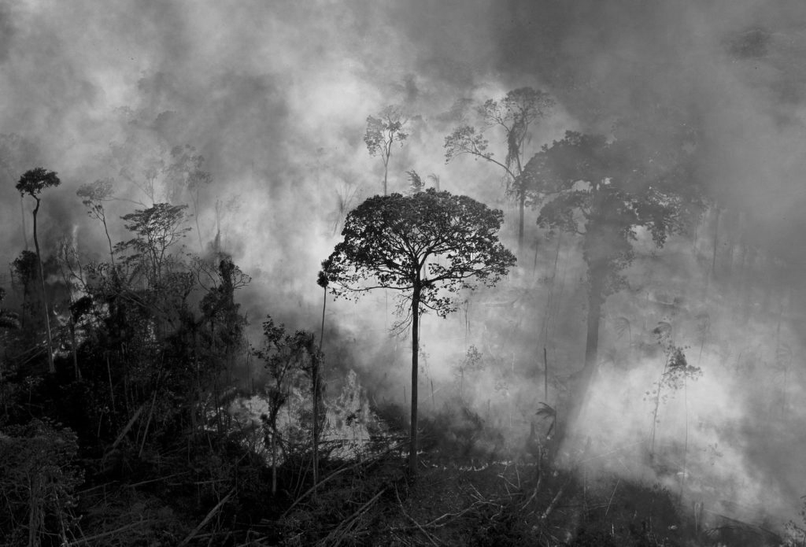
Source: https://www.pbs.org/newshour/world/as-record-acreage-burns-in-brazils-amazon-criminals-are-exploiting-rainforest-to-clear-land
Figure 1.
TOPSHOT – Smoke rises from an illegally lit fire in Amazon rainforest reserve, south of Novo Progresso in Para state, Brazil, on August 15, 2020. (Photo by CARL DE SOUZA / AFP) (Photo by CARL DE SOUZA/AFP via Getty Images)
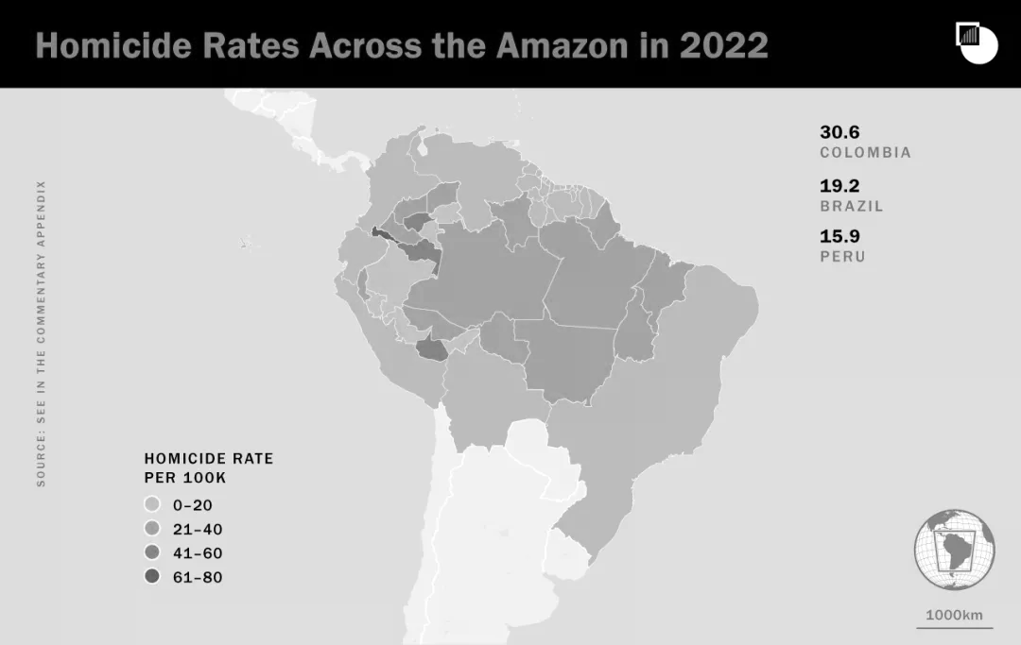
Source: https://www.crisisgroup.org/latin-america-caribbean/brazil-colombia/crimes-against-climate-violence-and-deforestation-amazon
Figure 2.
Homicides per hundred thousand people across the Amazon. In many countries, homicide rates within the Amazon are disproportionately high

Russia: Heatwaves, Pollution & the Rise in Violent Crime
Climate stress in Russia manifests through heatwaves and industrial pollution, both empirically linked to spikes in violent crime. Studies from CEPR and Transport Procedia demonstrate that extreme temperatures correlate with increased rates of assault and homicide, especially among young men in cities such as Volgograd, Astrakhan, and Rostov. These impacts are heightened in communities plagued by alcoholism, joblessness, and ineffective policing, conditions which are themselves the result of institutional weakness augmented by climatic shocks. Exposure to lead and transport particulates has also been proven to enhance neurotoxicity and impulsivity, further substantiating the relationship between environmental degradation and violent crime.
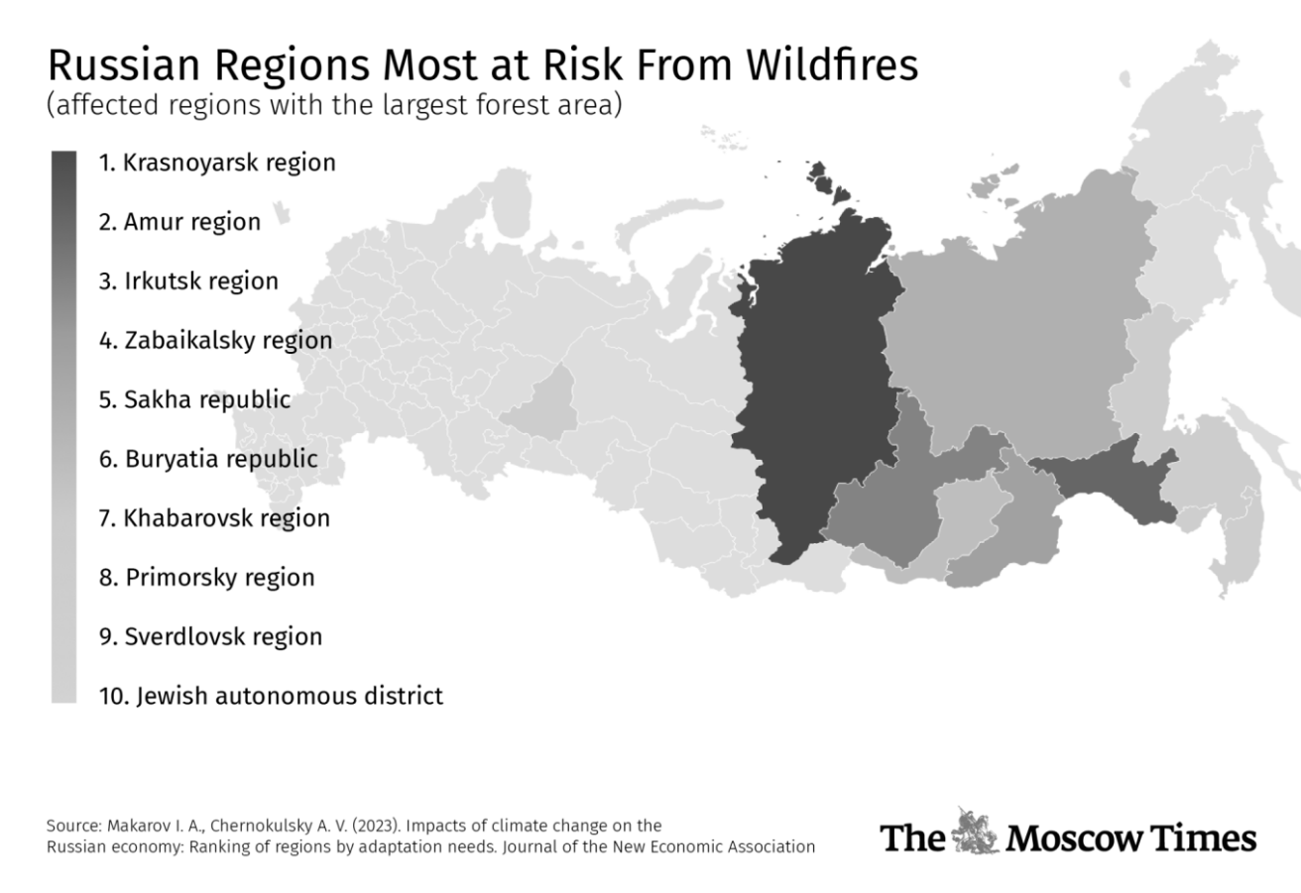
Figure 3.
Wildfire Prone Zones in Russia

India: Sundarbans to Slums – Climate Change Fuels Trafficking
In India’s Sundarbans region, repeated cyclones like Amphan and Bulbul have devastated coastal villages, leading to mass displacement and the erosion of legal identity among survivors. This has made communities, particularly women and children, highly vulnerable to exploitation. «Mysore Kallyanam» trafficking schemes, where marriages are arranged under false pretenses to extract dowry or force relocation, have thrived in such conditions. Despite the presence of Anti-Human Trafficking Units (AHTUs), understaffing, poor coordination, and post-disaster overload have rendered survivors invisible. One survivor from North 24 Parganas noted, “I was interviewed by three officers. No one heard me properly.” The institutional vacuum, paired with ecological vulnerability, has facilitated the rise of exploitative migration networks.
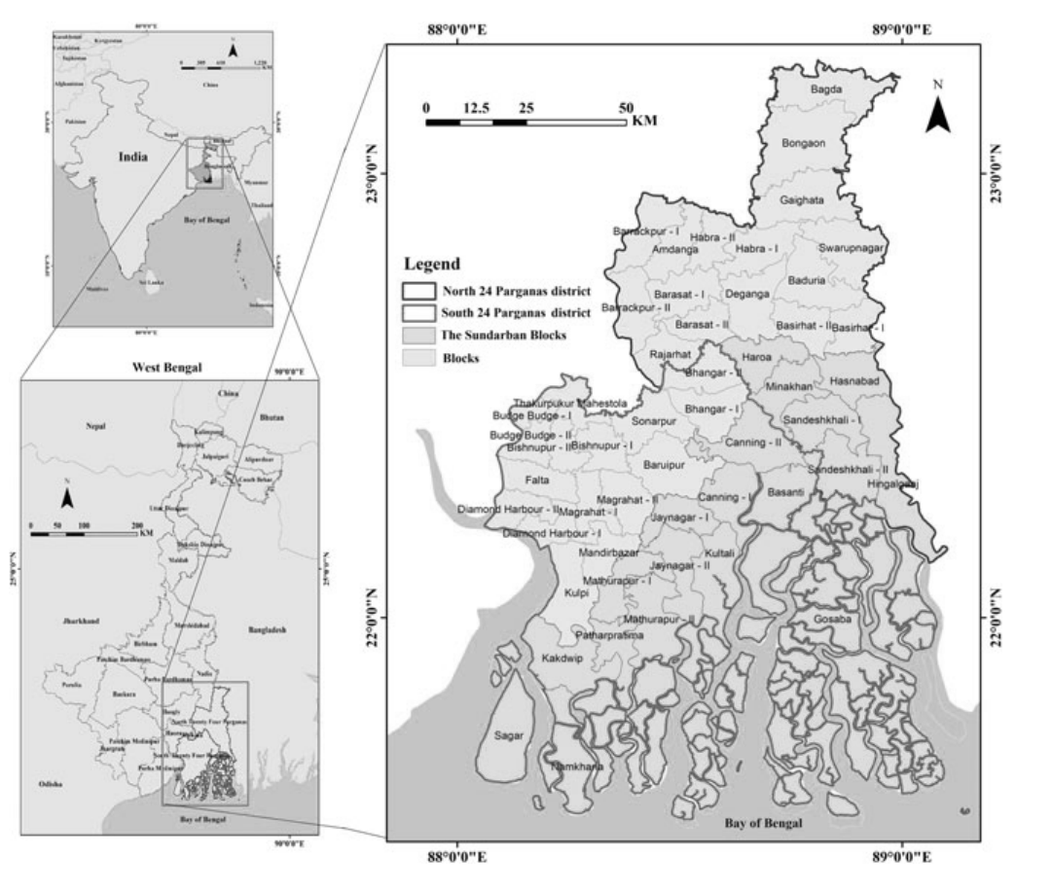
Source: https://doi.org/10.1007/978-981-16-2221-2_13
Figure 4.
The Sunderban Delta Region in India
China: Climate Extremes, Pollution & Crime Dynamics
China’s urban centers have witnessed a measurable increase in crime associated with both climate extremes and environmental pollution. A study covering 129 cities between 2013 and 2019 showed that a 1% rise in extreme weather events corresponds with a 0.035% increase in crime rates. Rural relocation brought on by agricultural collapse frequently drives this relationship, overloading urban networks and increasing rates of theft, violence, and trafficking. At the same time, environmental contamination is closely linked to violent and property crimes in 30 provinces, while social unrest and public mistrust are exacerbated by corruption and lax enforcement. Here, pollution is a criminogenic situation in addition to a health risk.
South Africa: Heatwaves, Droughts & Gendered Violence
South Africa presents a dual climate-crime risk profile: short-term heatwaves that trigger immediate violence and medium-term droughts that destabilize household and community life. According to Ankel-Peters et al. (2022), heatwaves lasting 3-5 days significantly raise rates of violent crime, with sexual assaults increasing by 8.6% during warmer nights. Simultaneously, extended droughts have increased resource-based conflict and intimate partner violence, especially in townships where social cohesiveness and infrastructure are weak. Among the most impacted are metropolitan areas like Cape Town, Johannesburg, and the Eastern Cape. These results, which demonstrate how rising temperatures activate both physiological and social causes of violence, provide compelling evidence in favor of the heat-aggression hypothesis.
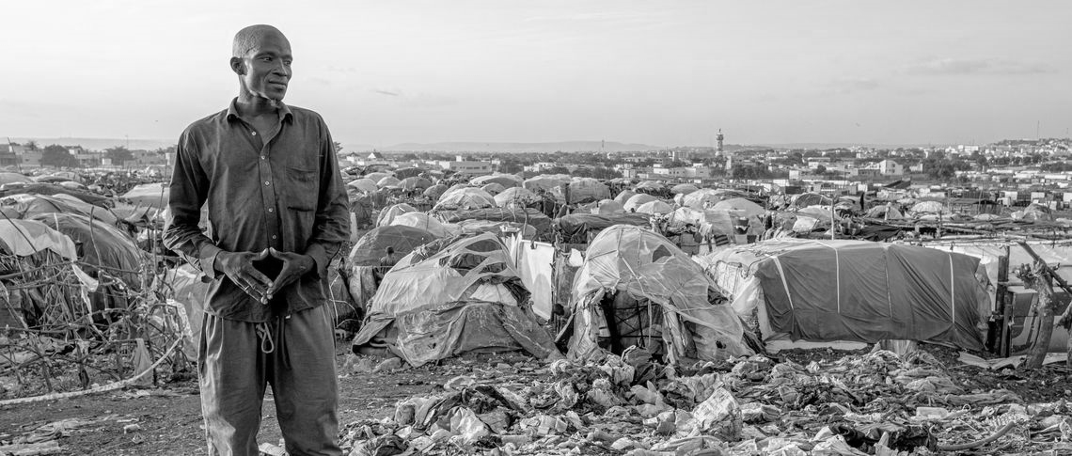
Source: https://www.ips-journal.eu/topics/economy-and-ecology/how-climate-change-fuels-conflicts-in-west-africa-6227/
Figure 5.
The crisis in the Sahel, Africa shows that wars fuelled by climate change could make earth a place unfit for life earlier than rising temperatures

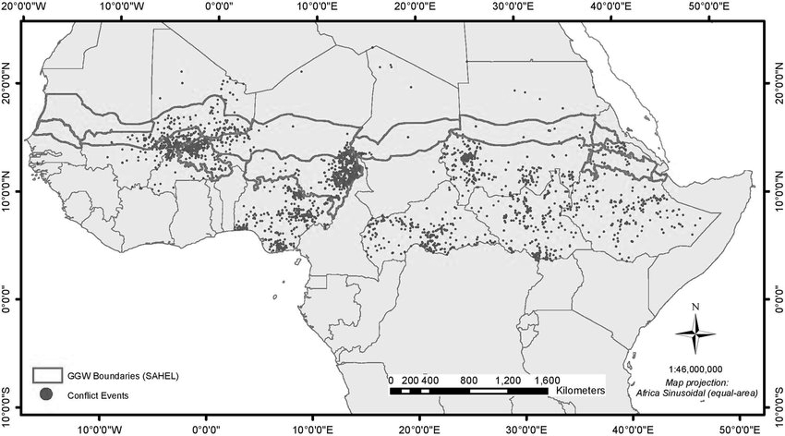
Source: https://www.nature.com/articles/s41893-021-00801-8
Figure 6.
Locations of violent conflicts across the Sahel region Note: The map shows the locations of incidences of violent conflicts and one-sided violence since 2015 exceeding 25 fatalities a year
BRICS Roadmap for Ecological Justice and CRIMEATE Resilience
To address the dual crises of climate change and emergent criminality, the CRIMEATE framework proposes a six-point roadmap designed for BRICS nations. First, a BRICS Climate and Crime Early Warning System should be established, integrating AI-powered disaster forecasts, satellite tracking of displacement zones, and community-based alert systems to enable proactive interventions before environmental crime and trafficking escalate. Second, trafficking risk assessments, including procedures for survivor protection, legal assistance, and coordinated action amongst welfare departments, civil society organizations, and Anti-Human Trafficking Units (AHTUs), must be included in national catastrophe frameworks. Third, the establishment of BRICS+ Joint Research Platforms is crucial for bringing together criminologists, social workers, and climate scientists to produce real-time data on ecological stress, survivor vulnerabilities, and crime trends in order to promote evidence-based, predictive policies. Fourth, cross-border Survivor-Centric Justice Models should be developed, mobile units capable of delivering trauma-informed care, legal identity restoration, and safe access to justice in displacement contexts. Fifth, CRIMEATE Resilience Units will guarantee early ecological crime identification, outreach, and prevention by being institutionalized inside the law enforcement, disaster response, and social welfare systems. Last but not least, the BRICS countries ought to work together to draft a Charter of Ecological Justice that harmonizes environmental safeguards with criminal law and human rights, encouraging common norms for moral responsibility, international collaboration, and long-term planetary resilience.
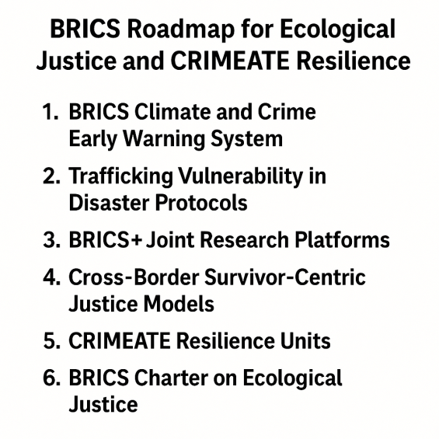
Source: Authors
Figure 7.
Roadmap for ecological justice

Road Ahead: A CRIMEATE – Aligned Quintuple Helix Vision
The path forward for ecological justice and crime prevention in BRICS nations requires more than reactive strategies, it demands an integrated, anticipatory model rooted in cross-sectoral collaboration. To this end, the CRIMEATE framework adopts the Quintuple Helix Model, a theoretical innovation proposed by Carayannis, Barth, and Campbell (2012), which conceptualizes knowledge and transformation as co-produced by five key stakeholders: government, academia, civil society, industry, and the natural environment. While the Quadruple Helix added the element of civil society and the traditional Triple Helix focused on university-industry-government relations, the Quintuple Helix takes a significant step forward by incorporating the natural environment as an active and epistemic actor that not only supports but also stimulates innovation. This approach encourages a socioecological transition, calling for socially inclusive and ecologically informed changes in the governance, economy, and society.
Within the CRIMEATE adaptation of this model, each helix is redefined through a criminological-environmental lens. Governments are positioned as enablers of climate-responsive policies and anti-human trafficking frameworks, accountable to both ecological and social justice. Academia becomes a hub for interdisciplinary research, generating data-driven insights that predict and mitigate climate-related criminal risks. Civil society emerges as the grassroots backbone, ensuring that interventions remain survivor-centered and culturally grounded. Industry is tasked with transforming production systems toward sustainability, ensuring corporate responsibility in curbing environmental crimes such as illegal mining, deforestation, and pollution. Uniquely, the natural environment is recognized as a rights-bearing stakeholder whose degradation not only signals ecological collapse but triggers structural violence and organized crime. By integrating these five helices into a circular, co-creative system (see Figure 8), the CRIMEATE roadmap offers a pragmatic and ethical blueprint for building resilience, equity, and safety in an era of planetary disruption.
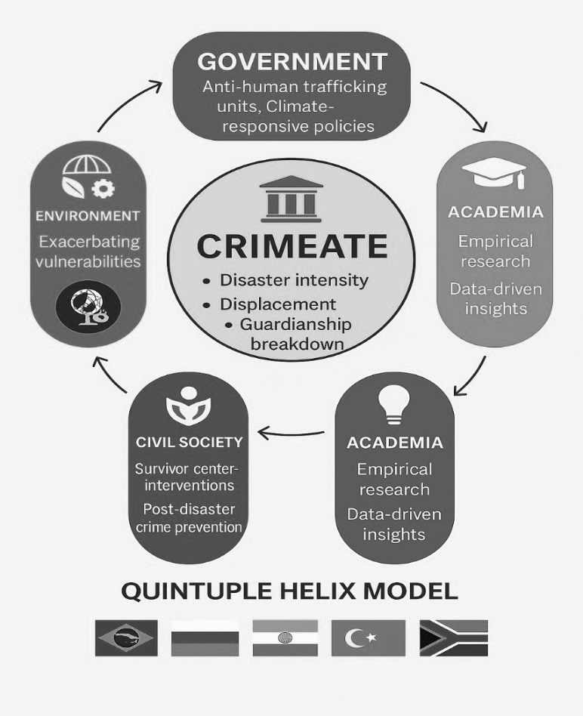
Source: Authors
Figure 8.
Quintuple Helix Model for Crimeate

Conclusion - A BRICS Call for Global Solidarity
The CRIMEATE framework offers more than a conceptual tool, it represents a paradigm shift toward anticipatory criminal-environmental justice. As BRICS nations grapple with the dual crises of ecological collapse and rising crime, reactive measures are no longer adequate. What is urgently needed is a coordinated, preventative, and survivor-centered response, one grounded in both rigorous scientific insight and deeply rooted grassroots engagement. Each sector within the Quintuple Helix ecosystem has a critical role to play. Academia must continue to lead interdisciplinary research, developing predictive models and validating localized interventions. Industry must undertake a green transition, ensuring ethical supply chains and resisting profit-making practices that exploit both nature and vulnerable populations. Government agencies must reform outdated criminal laws, incorporate ecological vulnerability into policing protocols, and mainstream climate risks into disaster governance. Civil society organizations are essential in anchoring justice, through survivor support, advocacy, and education, particularly for those rendered invisible by displacement or poverty. Crucially, the natural environment must be recognized not just as a passive backdrop but as a stakeholder, one whose degradation can no longer be separated from violence, inequality, or injustice. Together, we can transform climate vulnerability into resilience, and co-create a justice system that is not only reactive but ecologically awake, socially just, and globally connected.
References
- Agnew, R. Foundation for a general strain theory of crime and delinquency // Criminology. – 1992. – Vol. 30, N 1. – P. 47-88. https://doi.org/10.1111/j.1745-9125.1992.tb01093.x
- Anderson, C.A., Anderson, K.B., Dorr, N., DeNeve, K.M., Flanagan, M. Temperature and aggression // Advances in Experimental Social Psychology. – 2000. – Vol. 32. – P. 63-133. https://doi.org/10.1016/S0065-2601(00)80004-0
- Ankel-Peters, J., Devarajan, S., Fourie, J. Weather and crime – Cautious evidence from South Africa // Environment and Development Economics. – 2022. – Vol. 27, N 2. – P. 110-132. https://doi.org/10.1017/S1355770X22000018
- Berman, M.G., Jonides, J., Kaplan, S. The cognitive benefits of interacting with nature // Psychological Science. – 2020. – Vol. 19, N 12. – P. 1207-1212. https://doi.org/10.1111/j.1467-9280.2008.02225.x
- Block, M.L., Calderón-Garcidueñas, L. Air pollution: Mechanisms of neuroinflammation and CNS disease // Trends in Neurosciences. – 2009. – Vol. 32, N 9. – P. 506-516. https://doi.org/10.1016/j.tins.2009.05.009
- Carayannis, E.G., Barth, T.D., Campbell, D.F.J. The Quintuple Helix innovation model: Global warming as a challenge and driver for innovation // Journal of Innovation and Entrepreneurship. – 2012. – Vol. 1, N 2. https://doi.org/10.1186/2192-5372-1-2
- CEPR (Centre for Economic Policy Research) Heat and violence in post-Soviet Russia: Empirical evidence from panel data. CEPR Discussion Paper N 16792. – 2021.
- Cohen, L.E., Felson, M. Social change and crime rate trends: A routine activity approach // American Sociological Review. – 1979. – Vol. 44, N 4. – P. 588-608. https://www.jstor.org/stable/2094589
- Goldmann, E., Galea, S. Mental health consequences of disasters // Annual Review of Public Health. – 2014. – Vol. 35. – P. 169-183. https://doi.org/10.1146/annurev-publhealth-032013-182435
- Goya, C., Kajimoto, H. Attacks on Amazonian land defenders in Brazil // Global Environmental Politics. – 2023. – Vol. 23, N 1. – P. 102-117.
- Quetelet, A. A Treatise on Man and the Development of His Faculties. – Edinburgh: William and Robert Chambers, 1835.
- Sluchevskaya Yu., Kulikova A. Air pollution and violent crime // Transport Research Procedia. – 2022. – Vol. 63.

https://www.ips-journal.eu/topics/economy-and-ecology/how-climate-change-fuels-conflicts-in-west-africa-6227/
Quetelet, A. A Treatise on Man and the Development of His Faculties. – Edinburgh: William and Robert Chambers, 1835.
Cohen, L.E., Felson, M. Social change and crime rate trends: A routine activity approach // American Sociological Review. –1979. – Vol. 44, N 4. – P. 588-608. https://www.jstor.org/stable/2094589
Agnew, R. Foundation for a general strain theory of crime and delinquency // Criminology. – 1992. – Vol. 30, N 1. – P. 47-88. https://doi.org/10.1111/j.1745-9125.1992.tb01093.x
Anderson, C. A., Anderson, K. B., Dorr, N., DeNeve, K. M., Flanagan, M. Temperature and aggression // Advances in Experimental Social Psychology. – 2000. – Vol. 32. – P. 63-133. https://doi.org/10.1016/S0065-2601(00)80004-0
Goldmann, E., Galea, S. Mental health consequences of disasters // Annual Review of Public Health. – 2014. – Vol. 35. – P. 169-183. https://doi.org/10.1146/annurev-publhealth-032013-182435
Block, M.L., Calderón-Garcidueñas, L. Air pollution: Mechanisms of neuroinflammation and CNS disease // Trends in Neurosciences. – 2009. – Vol. 32, N 9. – P. 506-516. https://doi.org/10.1016/j.tins.2009.05.009
Goya, C., Kajimoto, H. Attacks on Amazonian land defenders in Brazil // Global Environmental Politics. – 2023. – Vol. 23, N 1. – P. 102-117.
Heat and violence in post-Soviet Russia: Empirical evidence from panel data. CEPR Discussion Paper N 16792 / Centre for Economic Policy Research. – 2021.
Shekhar B., Abdullah A. CRIMEATE and Human Trafficking: Understanding the Climate-Crime Nexus in India (unpublished, 2025).
Ankel-Peters, J., Devarajan, S., Fourie, J. Weather and crime – Cautious evidence from South Africa // Environment and Development Economics. – 2022. – Vol. 27, N 2. – P. 110-132. https://doi.org/10.1017/S1355770X22000018
Carayannis, E. G., Barth, T. D., & Campbell, D. F. J. (2012). The Quintuple Helix innovation model: Global warming as a challenge and driver for innovation. Journal of Innovation and Entrepreneurship, 1(2). https://doi.org/10.1186/2192-5372-1-2

