Khachatryan L.
Candidate of Economics, Associate Professor, Deputy Director for Science, Institute of Economics of the National Academy of Sciences of the Republic of Armenia, Yerevan lianakhachatryanforjob@gmail.com

THE RELATIONSHIP BETWEEN EDUCATION AND POVERTY: ANALYSIS IN THE REPUBLIC OF ARMENIA

Keywords: education, poverty, factors hindering education, professional orientation, education-business connection, professional target locations.

Introduction
The poverty level is considered a key indicator that assess the well-being and standard of living of the population of countries, as well as economic stability. In the RA the poor are identified as those with consumption per adult equivalent below the average poverty line, which is the average of the lower and upper poverty lines; whereas the extremely poor or the undernourished are defined as those with consumption per adult equivalent below the food poverty line. Poverty, as a multifaceted economic indicator, including social, economic and cultural dimensions, directly determines limited access to education, healthcare and other social services. In turn, education plays a key role in improving the living standards and economic well-being of the population, affecting various aspects of people's lives and society as a whole.
The aim of the study is to identify the relationship between education and poverty, for which a number of questions were studied. In particular: how does education affect the level of poverty, and conversely, does poverty hinder a person's educational opportunities? Can expanding education help improve people's economic status? How difficult is it for children in poor families to receive an education, as a result of which the persistent low standard of living across generations in poor families is maintained?
The main goal is also to find ways to mitigate the impact of the poverty factor that hinders education as a result of the research.
Methodology
The theoretical and methodological basis for the research was the works of economic researchers, articles, conference proceedings, and a number of theories. The relationship between education and economic status was studied on the basics of human capital theory. Signalling theory was also adopted as a basis, according to which education provides employers with an idea of future technological progress as a signal. The social aspects of human capital development, conditioned by educational achievements, were studied based on Social Capital theory. Statistical data collection, as well as comparative, analytical, and descriptive methods, were used during the study of the relationship between education and poverty. The research database is based on the publications of the RA Statistical Committee.
Analysis
In the 1990s Italian economist Daniele Cecchin and German sociologist Jutta Allmendinger introduced the concept of educational poverty.
The problem of poverty and its connection with restrictions on access to educational services exists worldwide. For this reason, both international organizations and national governments propose strategies aimed at solving this problem. It is a well-known fact that income inequality remains a clear indicator of inequality of opportunities, including educational opportunities in general and quality education in particular.
There is general agreement that education is responsible for the common good. Poverty is inevitably linked to low levels of education, poor quality of work, or inadequate design of economic policies for income redistribution. A vicious circle is created, the links of which include income poverty, low wages, unstable and poor-quality education, poor-quality health care, etc.
The quality of human capital is most often measured in terms of the number of years spent in education. The global average return to education is 10%, meaning that each additional year of education increases a person's future earnings by 10% on average, with this figure typically higher in developing countries.
In the case of educational inequality, measures should be aimed at ensuring fair conditions for all social groups to receive education, equalizing starting conditions. The elimination of educational poverty should stem from the logic of social policy, with measures aimed at those individuals whose education is below the minimum level.
Education is one of the main factors contributing to the socio-economic development of a society. Its impact covers many aspects, from individual well-being to social changes. In turn, the socio-economic level of a country determines the opportunity to receive education and the quality of education provided.
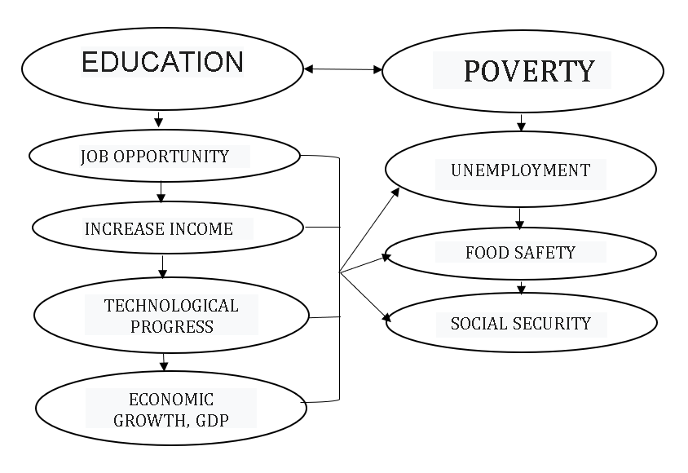Figure 1.
Socio-economic correlation between education and poverty

Obtaining first-level higher education and the quality of education are directly determined by the well-being of the family, and families living in poverty face a number of obstacles. As a result of the research conducted, the factors affecting access to education can be presented in the following classification:
1. Financial factors – Providing a child with higher education requires a significant capital investment from parents, especially when the HEI is located far from the place of residence, requiring tuition fees, transportation expenses, daily expenses, and sometimes even rented accommodation. Depending on the specialization and the degree of recognition of the diploma awarded, annual tuition fees at operating HEIs range from 400 thousand drams to 2 million drams. Compared to European universities, tuition fees in Armenia are not set high, but the unemployment rate in the Republic, the average monthly salary, and the cost of the food and consumer basket should be taken into account. The monthly tuition fee at universities offering medical, legal, and information technology specialties, which have been in high demand in recent years, is 80-200 thousand drams, while the minimum consumer basket is calculated at only 75,529.3 drams.
Table 1
Main Indicators Characterizing the Economic Situation of the Republic
Indicators | 2013 | 2018 | 2023
Unemployment Rate | 16,2 | 19,0 | 13,5
Extremely poor, % | 2,7 | 1,0 | 1,2
Very poor, % | 13,3 | 9,6 | -
Poor, % | 32,0 | 23,5 | 24,8
average monthly salary, AMD | 146524 | 172727 | 269994
Food basket: annual, AMD | 383 731.0 | 409 452.0 | 489 919.7
food basket: monthly, AMD | 31 977.6 | 34 121.0 | 40 826.6
Minimum consumer basket: annual, AMD | 679 203.9 | 724 730.0 | 906 351.4
Minimum consumer basket: monthly, AMD | 56 600.3 | 60 394.2 | 75 529.3

2. Social factors – Another common factor hindering education is the social status of families and the lack of support for these families from the state. In families of low social status, the importance of higher education is particularly absent, which leads to insufficient motivation for children. In such families, children are often responsible for household chores, which limits their time for learning.
3. Geographical factors – Urban areas tend to have more resources, programs, and opportunities for quality education. Children living in remote rural areas are hindered from accessing higher education due to the low quality of education provided in schools, which affects their ability to pass university entrance exams. On the other hand, public and private higher education institutions operating in Armenia are mainly located in the capital, Yerevan, which limits the number of students.
4. Cultural factors – Unfortunately, in modern Armenia, “traditional views on education” still prevail, there are some “necessity of education” or “gender-based” beliefs about choosing a profession. From remote rural areas, even in cases of financial security, Families find it difficult to send their daughters to the capital to receive a higher education.
Table 2
Dynamics of Admissions to RA Higher Education Institutions
The RA Regions and the City of Yerevan | Distance of the regional centre from the capital, km | 2013 |  | 2018 |  | 2023
The RA Regions and the City of Yerevan | Distance of the regional centre from the capital, km | Number of state and private HEIs and branches , | Number of students in state, private HEIs and branches | Number of state and private HEIs and branches | Number of students in state, private HEIs and branches | Number of state and private HEIs and branches | Number of students in state, private HEIs and branches
Yerevan | - | 51 | 71559 | 45 | 59036 | 44 | 63238
Aragatsotn | 19 | - | 0 | - | 0 | - | 0
Ararat | 30 | - | 0 | - | 0 | - | 0
Armavir | 44 | 2 | 310 | 1 | 93 | 1 | 79
Gegharquniq | 92 | 2 | 1740 | 2 | 952 | 2 | 771
Lori | 115 | 4 | 3622 | 4 | 2901 | 4 | 2101
Kotayk | 50 | 2 | 415 | 1 | 183 | 1 | 357
Shirak | 118 | 7 | 4752 | 8 | 3238 | 8 | 3159
Syunik | 301 | 4 | 1772 | 4 | 1582 | 4 | 1106
Vayoc Dzor | 123 | 1 | 159 | 1 | 218 | 1 | 114
Tavush | 133 | 2 | 1593 | 2 | 1419 | 2 | 1133
Total | - | 75 | 85922 | 68 | 69622 | 67 | 72058

Conclusion
The availability and quality of higher education, which are crucial for economic development, are directly determined by the financial security of families. At the same time, it has been proven that specialists with higher education are in greater demand and receive higher salaries. There is a chain where education is determined by the level of poverty, and we can overcome poverty through education. An "invisible hand" is needed, which, through its functions, can mitigate the interaction of these factors.
We offer:
Connection between Education and Business. Considering the main factor hindering education – the financial situation of the family – the government could establish certain privileges for organizations that create connections with universities. To replenish and rejuvenate the workforce in organizations, contracts could be signed with students enrolled in educational programs for in-demand specialties. The main condition in the contract could be that the student will reimburse the total tuition fee for the years of study after starting work in the organization, part by part, from the salary.
Allocating targeted places in universities with state funding. In recent years, the Republic has seen a decrease in demand, especially for agricultural specialties. Thus, in 2017, 67 students graduated from the bachelor's degree program in the specialty "Veterinary Medicine," in 2019 – 57 students, in the 2022-2023 academic year, 26 students were admitted, and in 2023-2024, 18 students. Taking into account the importance of the veterinary profession and its shortage in the regions, a list of professions funded by the government can be presented in high schools in rural communities. A professional orientation process can be organized, and students participating in the program can be selected. Such a mechanism can be used not only for specialists in the agrarian sector but also in cases of a shortage of labour in any profession in rural communities – teachers of natural sciences, doctors, etc.

Food Security and Poverty, January-June 2024 / Statistical Committee Republic of Armenia. – 2024. – P. 109, 101. – https://armstat.am/file/article/f_sec_2_2024_5.pdf
Botezat A. Educational poverty. – https://nesetweb.eu/wp-content/uploads/2019/06/AHQ5_Educational-Poverty.pdf
Косарецкий С.Г., Пинская М.А., Груничева И.Г. Проблемы бедности и доступа к образованию. Оценка ситуации в России и международный опыт // Мир России. – 2014. – № 2. – https://cyberleninka.ru/article/n/problemy-bednosti-i-dostupa-k-obrazovaniyu-otsenka-situatsii-v-rossii-i-mezhdunarodnyy-opyt/viewer
Marginson S. Higher Education and Public and Common Good / Centre for Global Higher Education Working Paper series. – 2024. – N 114. – https://www.researchcghe.org/wp-content/uploads/migrate/wp114-1.pdf
Sanz R, Peris J.A., Escámez J. Higher education in the fight against poverty from the capabilities approach: The case of Spain // Journal of Innovation & Knowledge. – 2017. – https://sci-hub.se/https://doi.org/10.1016/j.jik.2017.03.002
Demyanenko V. Income and Poverty of Highly Educated Professionals in Russia // Economic Conversations. – 2022. – N 9. – https://econs.online/en/articles/economics/income-and-poverty-of-highly-educated-professionals-in-Russia/
Бутовская З.С., Косарецкий С.Г., Звягинцев Р.С. Образовательная бедность в РФ: проблемы измерения и оценки. – 2022. – https://edpolicy.ranepa.ru/obrazovatelnaya-bednost-v-rf-problemy-izmereniya-i-ocenki
https://radar.am/hy/news/social-2571330984/
Unemployment Rate by indicators and years / Statistical Committee Republic of Armenia. – https://statbank.armstat.am/pxweb/en/ArmStatBank/ArmStatBank__2%20Population%20and%20social%20processes__23%20Employment%20and%20unemployment/PS-eu-1-2022.px/table/tableViewLayout2/?rxid=9ba7b0d1-2ff8-40fa-a309-fae01ea885bb
The data for 2023 was not summarized, the data for 2022 is presented.
Social Snapshot and Poverty in Armenia / Statistical Committee Republic of Armenia. – 2024, 2019, 2014. – https://armstat.am/file/article/5.poverty_2014a_2.pdf; https://armstat.am/file/article/poverty_2019_a_2.pdf
The data for 2023 was not summarized, the data for 2022 is presented.
Time series, Average monthly nominal weges / Statistical Committee Republic of Armenia. – 2024. – https://armstat.am/en/?nid=12&id=08001
The socio-economic situation of the republic of Armenia / Statistical Committee Republic of Armenia. – 2024, 2019, 2014. – https://armstat.am/file/article/sv_09_24a_6200.pdf; https://armstat.am/file/article/sv_09_19a_6200.pdf; https://armstat.am/file/article/sv_09_14a_6200.pdf
Marzes of the Republic of Armenia and Yerevan city in figures / Statistical Committee Republic of Armenia. – 2023.
Number of state educational institutions and branches by indicators, marzes and years / Statistical Committee Republic of Armenia.
Number of non-state educational institutions and branches by indicators, marzes and years / Statistical Committee Republic of Armenia.
Number of students of state educational institutions by indicators, marzes and years / Statistical Committee Republic of Armenia.
Ibid.
Ibid.
Social Situation of RA in 2017 (Armenian) / Statistical Committee Republic of Armenia. – https://armstat.am/file/article/soc_vich_2017_6.pdf
Social Situation of RA in 2019 / Statistical Committee Republic of Armenia. – https://armstat.am/file/article/soc_vich_2019_6.pdf
Social Situation of RA in 2022 / Statistical Committee Republic of Armenia. – https://armstat.am/file/article/soc_sit_2022_6.pdf
Social Situation of RA in 2023 / Statistical Committee Republic of Armenia. – https://armstat.am/file/article/soc_sit_2023_6.pdf

