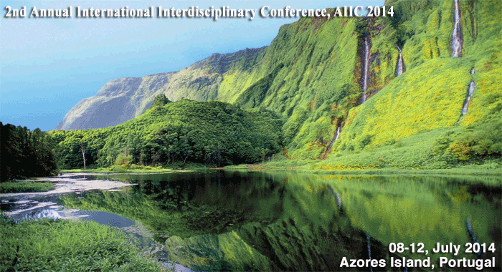

2nd Annual International Interdisciplinary Conference, AIIC 2014
08-12 July 2014, Azores Islands, Portugal
CALL FOR PAPERS
After the successful 1st Annual International Interdisciplinary Conference, AIIC 2013, 24-26 April, which gathered over 400 scientific articles by researchers from more than 100 countries all around the globe, the European Scientific Institute, ESI, University of the Azores and Center for Law and Economic Studies, CEJE are inviting you to attend the AIIC 2014 which will be held at the University of the Azores in Ponta Delgada.
The 2nd Annual International Interdisciplinary Conference AIIC 2014 will be a kind of academic bridge between different cultures, scientific attitudes, academic stages and is aimed at gathering researchers from all around the world, thus contributing for a global flow of the newest scientific thoughts and promotion of the interdisciplinary concept.
Supporting the concept of interdisciplinarity we welcome submissions in all academic areas.
All accepted papers will be published as a specific publication with an ISBN number. The author will be sent a printed copy of the proceedings after the conference finishes.
Special Social Programme for the participants will be provided and covered by the organizers.
http://aiiconference.net/index.php/2013-07-25-22-03-59
The papers will be also published in a special edition in of one of the most prominent scientific journals in Europe, the European Scientific Journal (ESJ).

